

**NAMA : SHABRINA QOTTRUNNADA**

**KELAS : 1G**

**ABSEN : 24**

**NIM : 2341760160**

**JOBSHEET 10**

EXPERIMENT 1

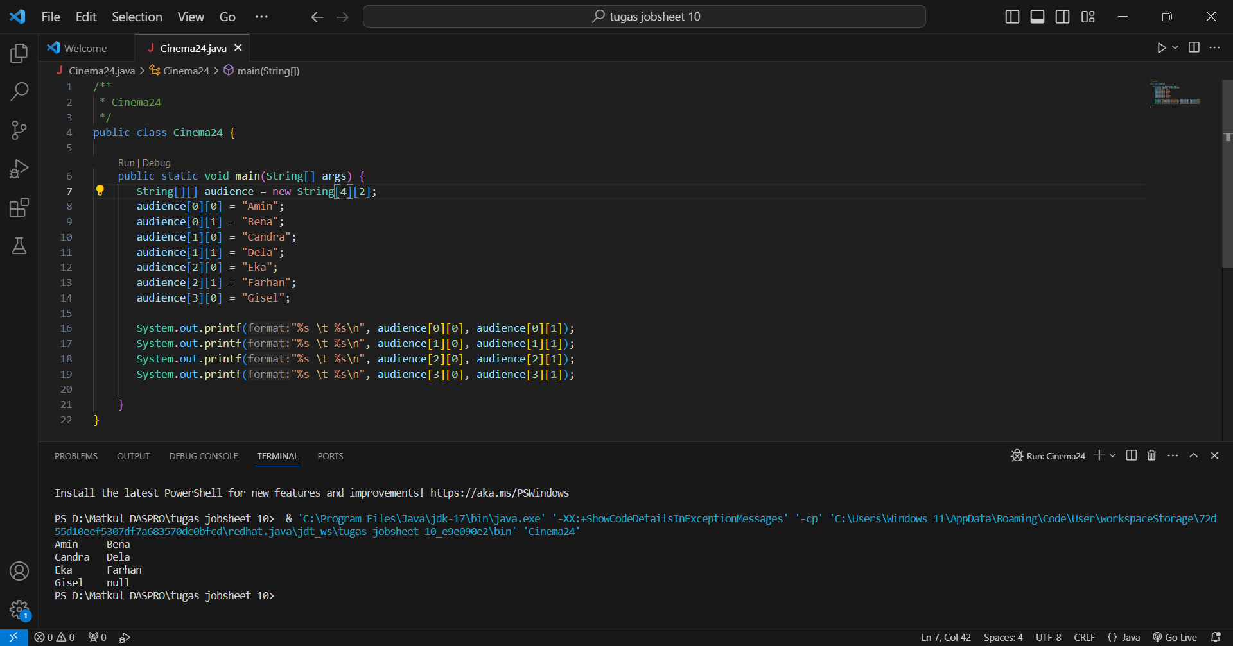

Questions!

1. Do array elements have to be filled in sequentially starting from the 0th index? Please explain!

No, because array elements don't always have to be filled sequentially starting from index 0, why? because in programming it supports flexible data.

1. Why is there a null in the list of audience names?

because in the list of audience names there is no input of the name, so the result becomes null.

1. Complete the audience list in step 4 so that it looks like the following program code.

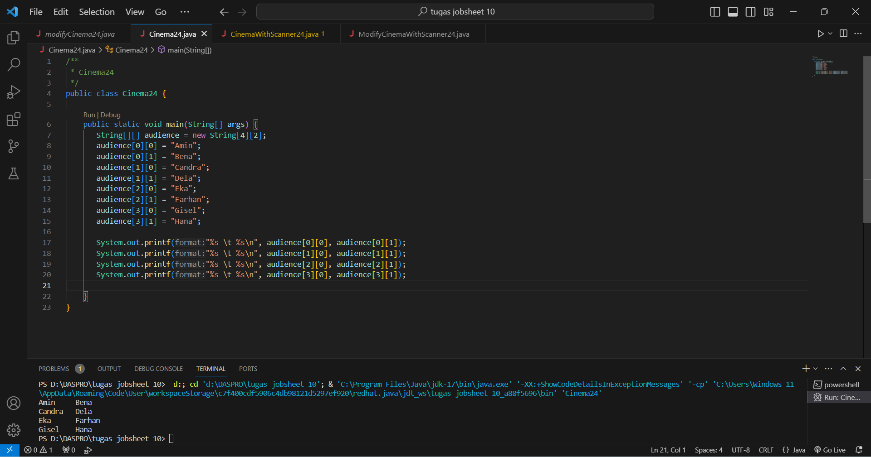

1. Add the following program code:

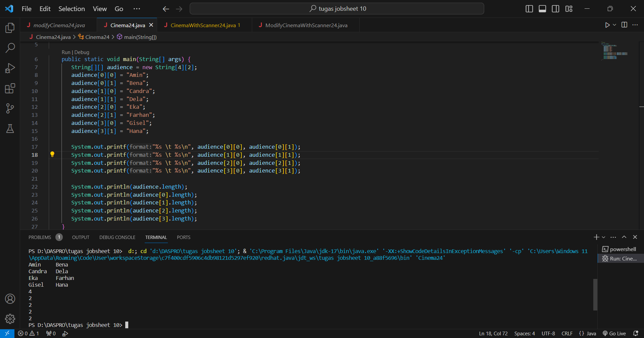

Explain the function of audience.length and audience[0].length! Do audience[0].length, audience[1].length, audience[2].length, and audience[3].length have the same value? Why?

* The function of audience.length is to extend the number of elements in the audience element.
* The function of audience[0].length is to give the length of the string at index 0 of audience.
* audience[0].length, audience[1].length, audience[2].length, and audience[3].length have the same value, because the properties both use length, the only thing that is different is the object contained at the index in the audience array.

1. Modify the program code in step 4 to display the length of each row in the array using a for loop. Compile, run, then commit.

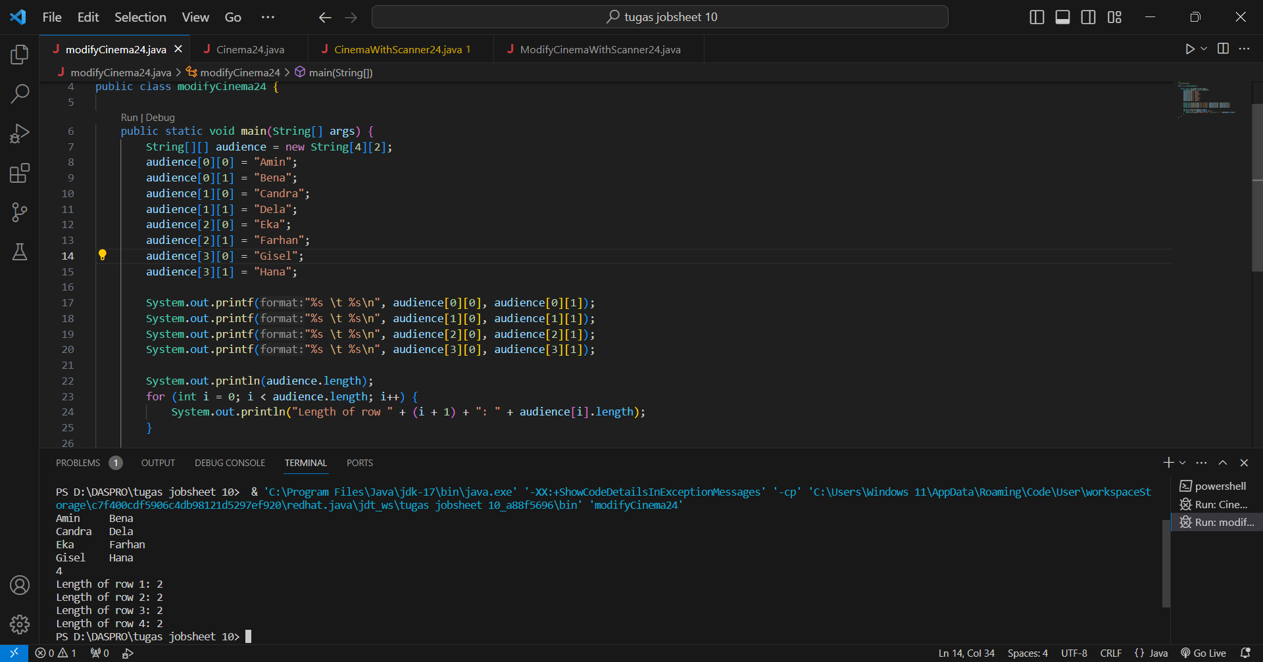

1. Modify the program code in step 5 to display the length of each row in the array using a foreach loop. Compile, run, then commit.

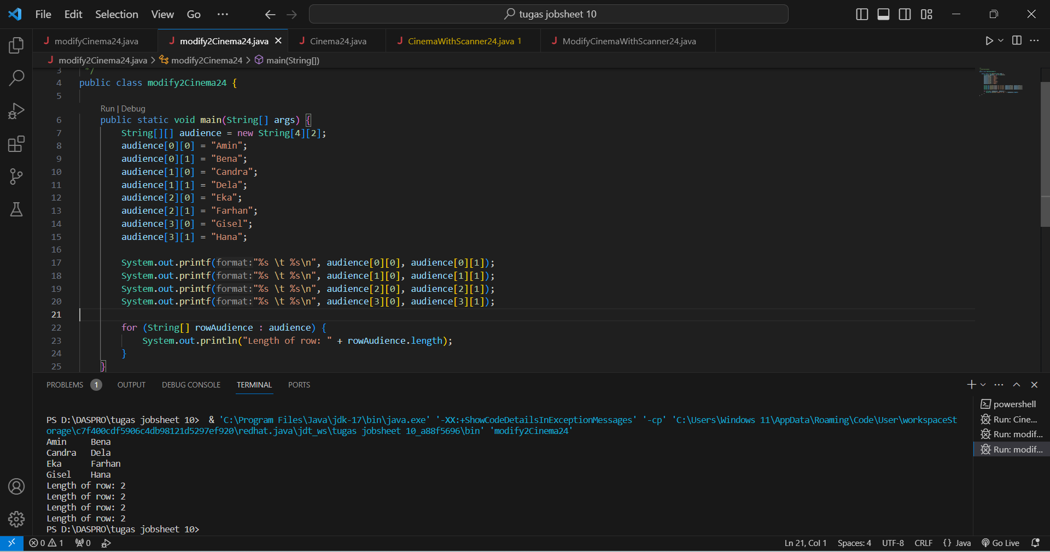

1. In your opinion, what are the advantages and disadvantages of foreach loop compared to for loop?

In my opinion

* Advantages

1. Foreach Loop

* The foreach loop to avoid the risk of infinite looping
* The foreach loop is easier to read than the for loop

1. For Loop

* In the for loop, we can control the index as we wish
* Disadvantages

1. Foreach Loop

* If we use a foreach loop and want to manipulate the element index, then foreach cannot provide direct access to the element index.

1. For Loop

* If we use the for loop manually the index can cause a risk of misidentifying it.

1. What is the max row index for the audience array?

The maximum row index for the audience array is the length of the array 4 and minus 1 (because the index starts from 0), the maximum row index is 3.

1. What is the max column index for the audience array?

The maximum column index for the audience array is 1, because the columns are declared as String[4][2], then each row is 2 columns since the indices start from 0 and 1.

1. Add program code to display the audience’s name on the 3rd line using a for loop. Compile, run, then commit.

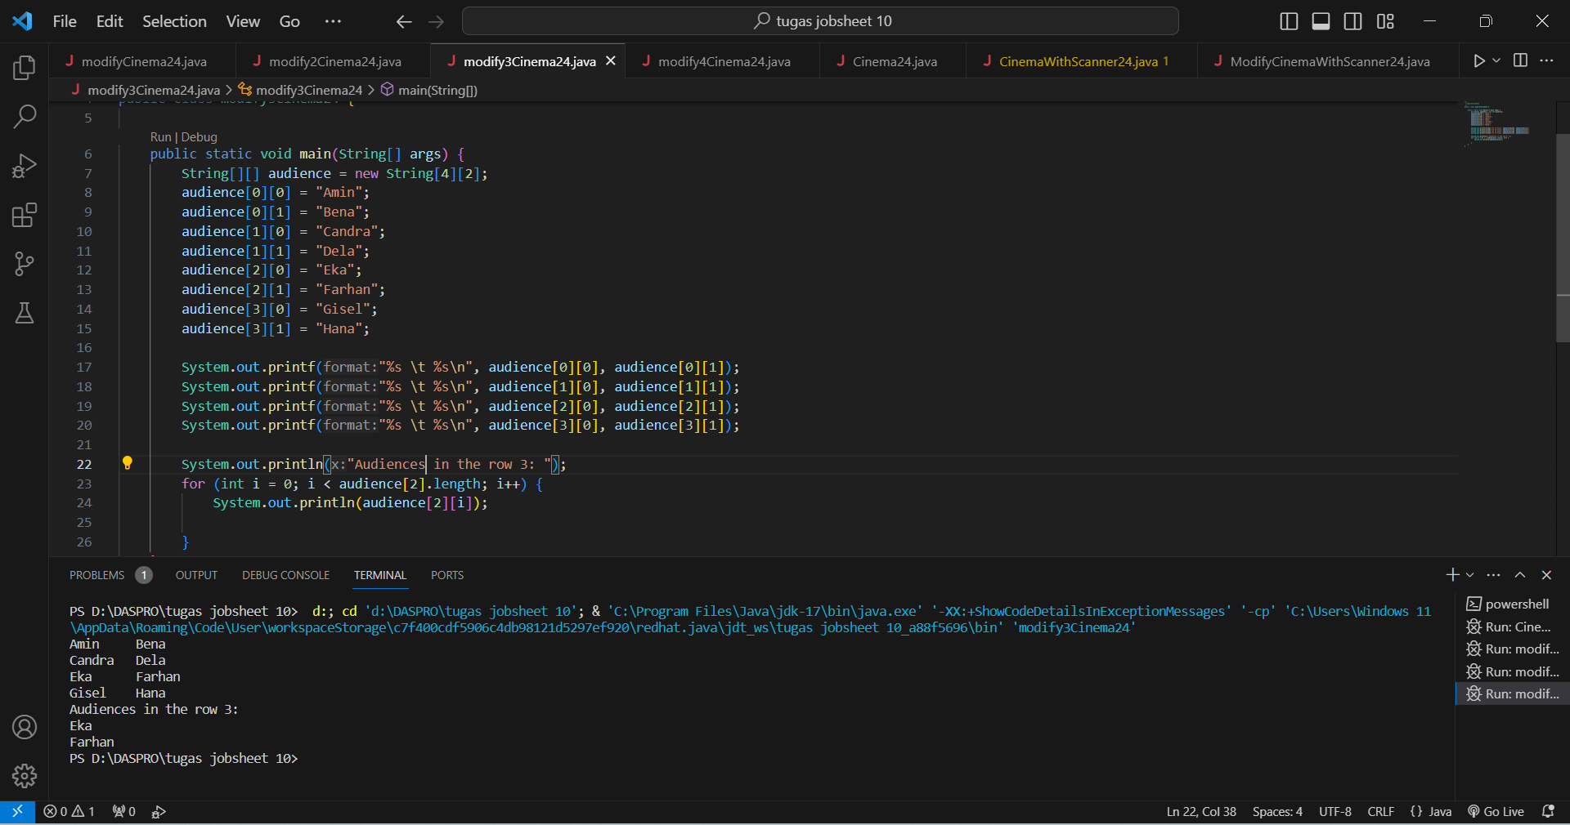

1. Modify the code in question number 10 to repeat using a foreach loop. Compile, run, then commit.

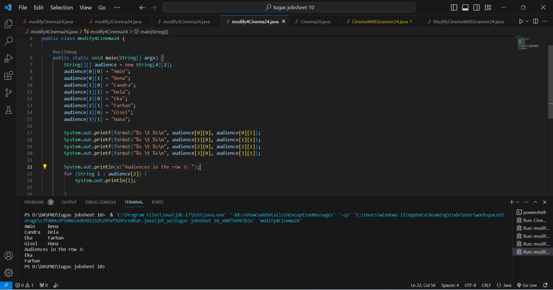

1. Modify the program code in question number 11 again to display the audience’s name for each line. Compile and run the program then observe the results, then commit.

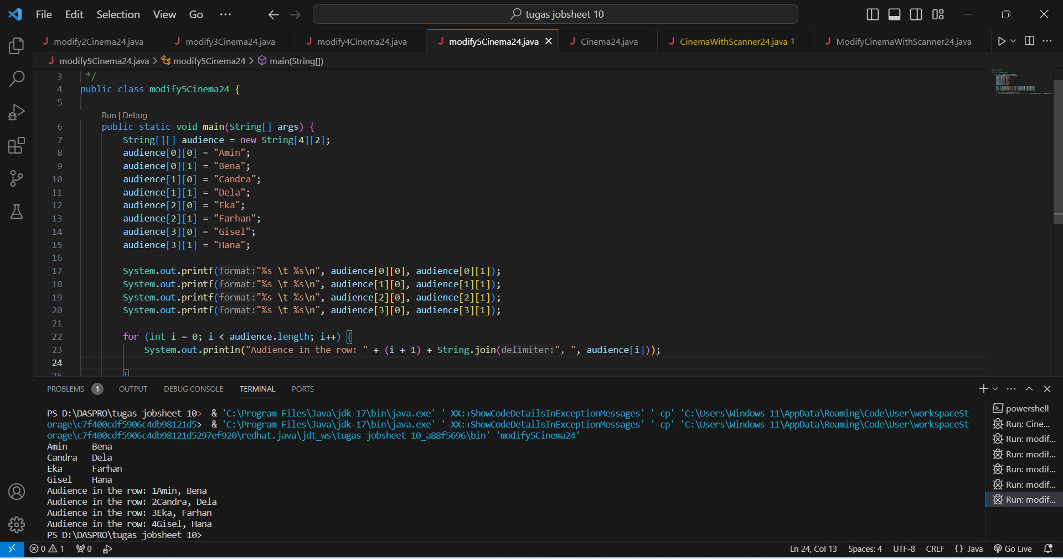

1. What is the function of String.join()?

The function of String.join() is to connect or combine multiple strings into a single string.

1. Commit and push to GitHub

EXPERIMENT 2

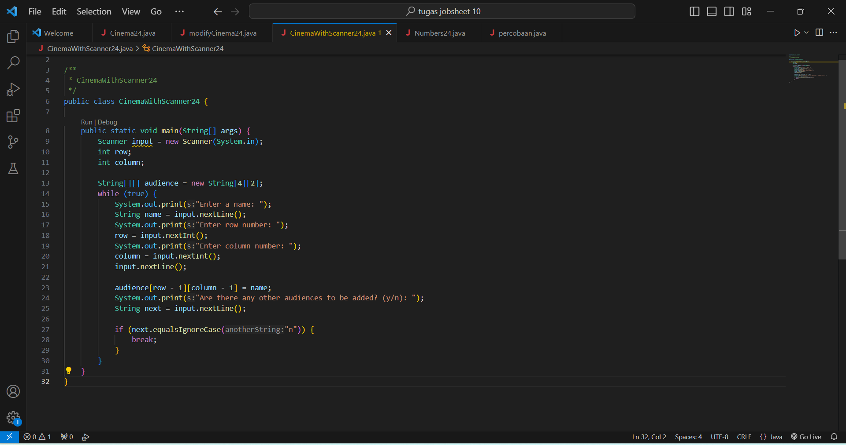

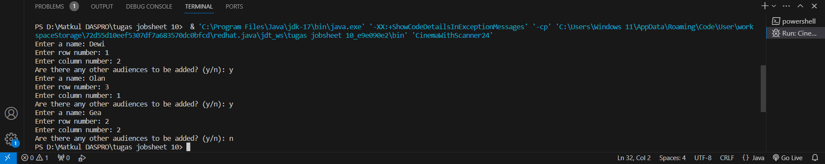

Questions!

1. Should the array elements from the scanner be filled in sequentially starting from the 0th index? Please explain!

Yes, the array elements from the scanner should be filled sequentially starting from index 0 and will later be filled by the next element until the last index.

1. Modify the program code to provide the following menu options:

- Menu 1: Input audience data

- Menu 2: Show audience list

- Menu 3: Exit

1. Modify the program code to handle if the seat row/column number is not available
2. In menu 1, modify the program code to give a warning if the selected seat is already occupied by other audiences, then display a command to enter rows and columns again
3. In menu 2, if the seat is empty, replace null with ***
4. Commit and push the program code to GitHub.

* Input program code

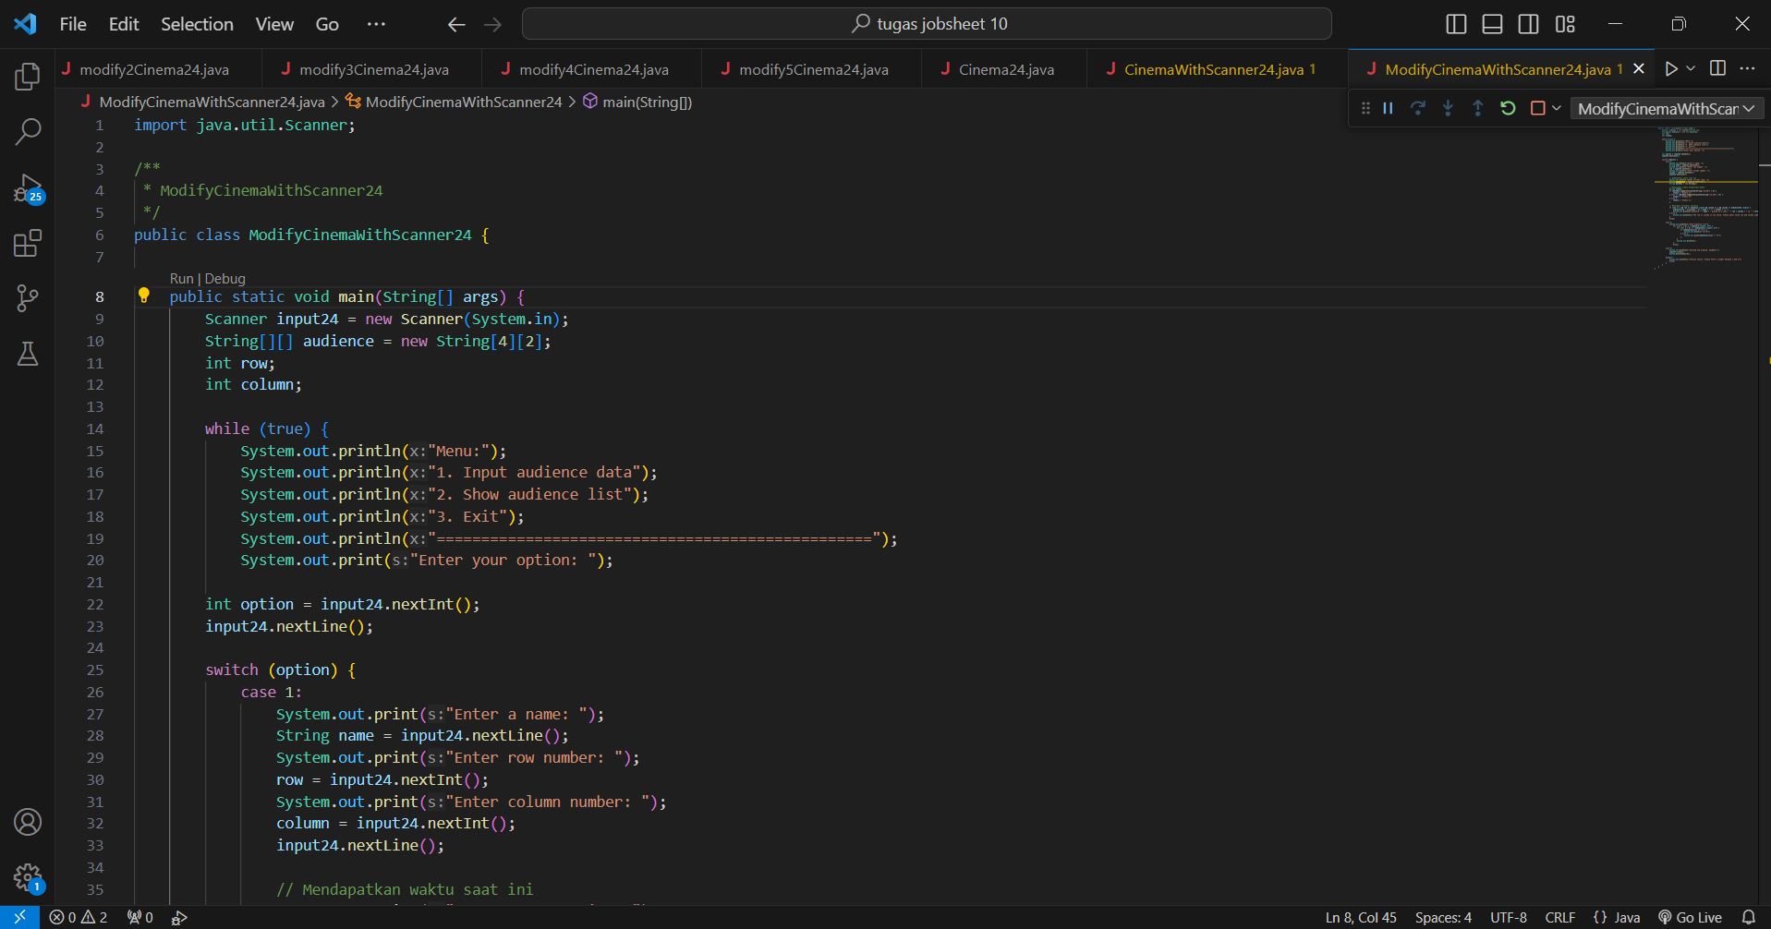

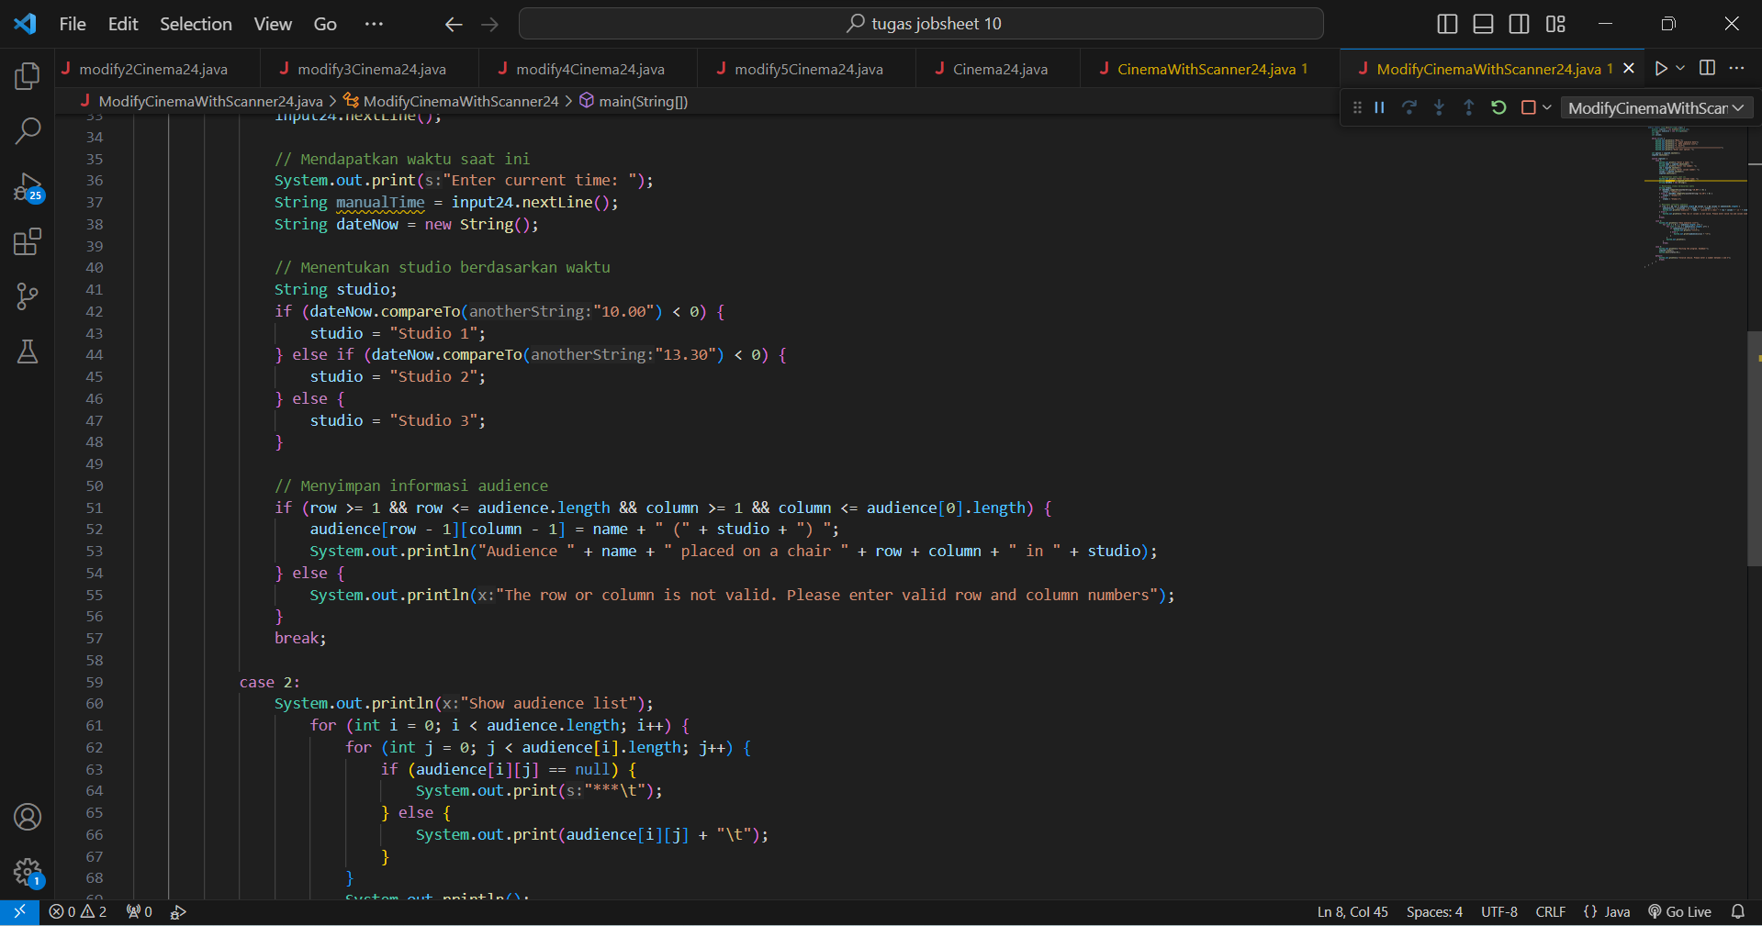

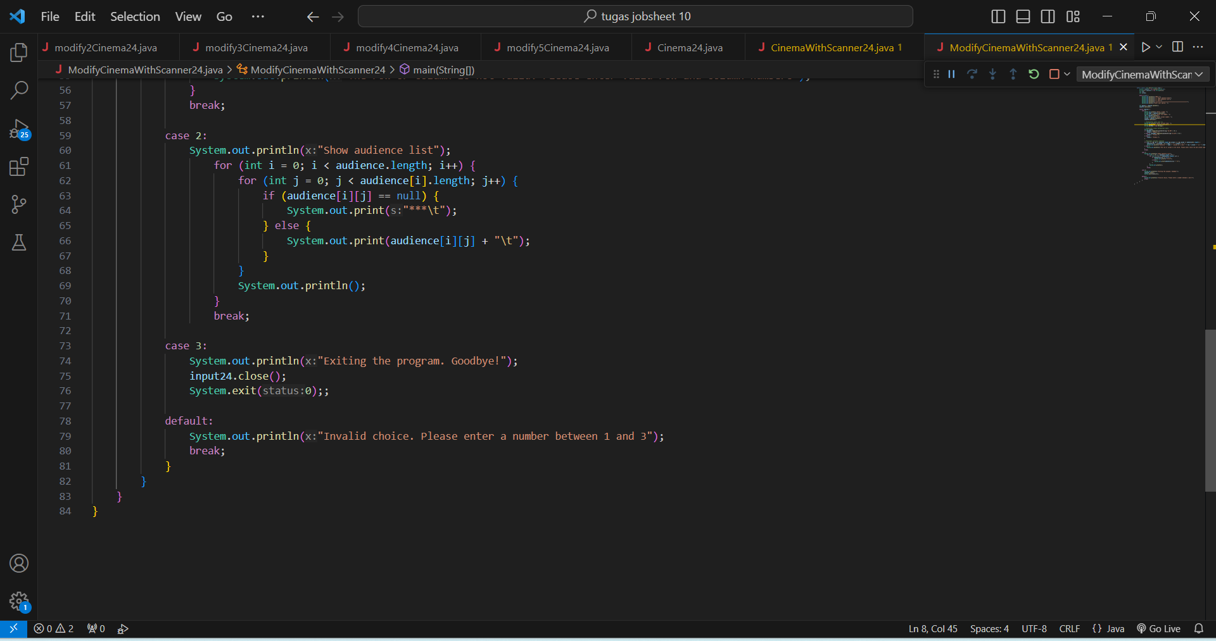

* Output program code

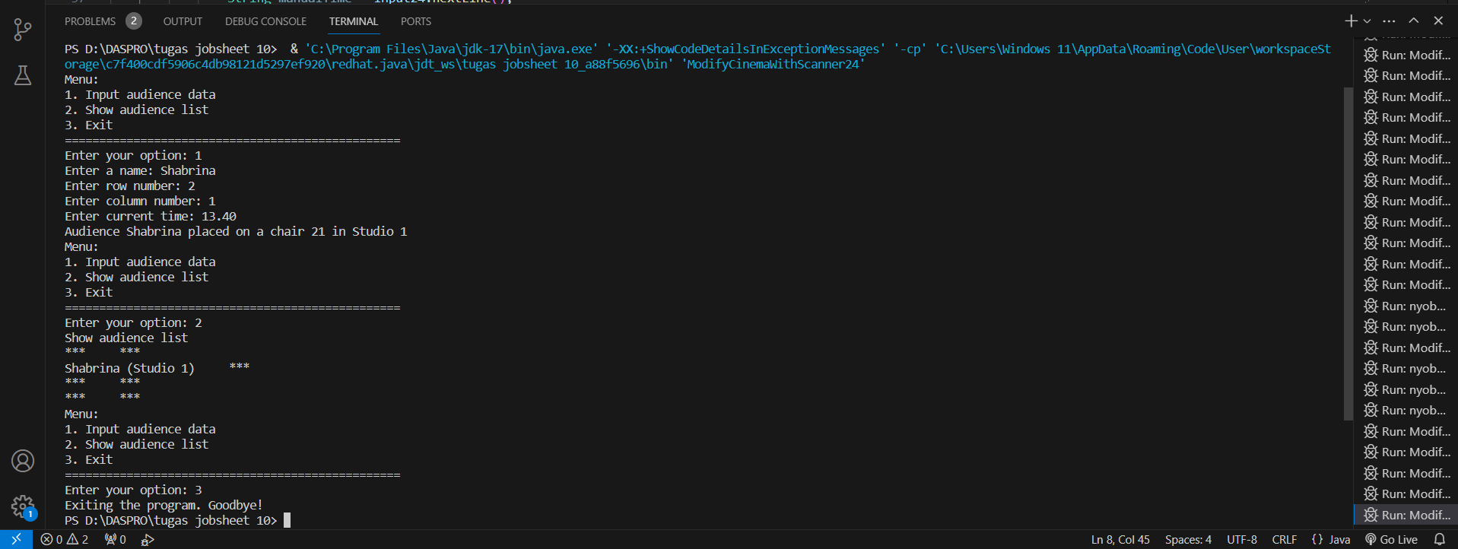

EXPERIMENT 3

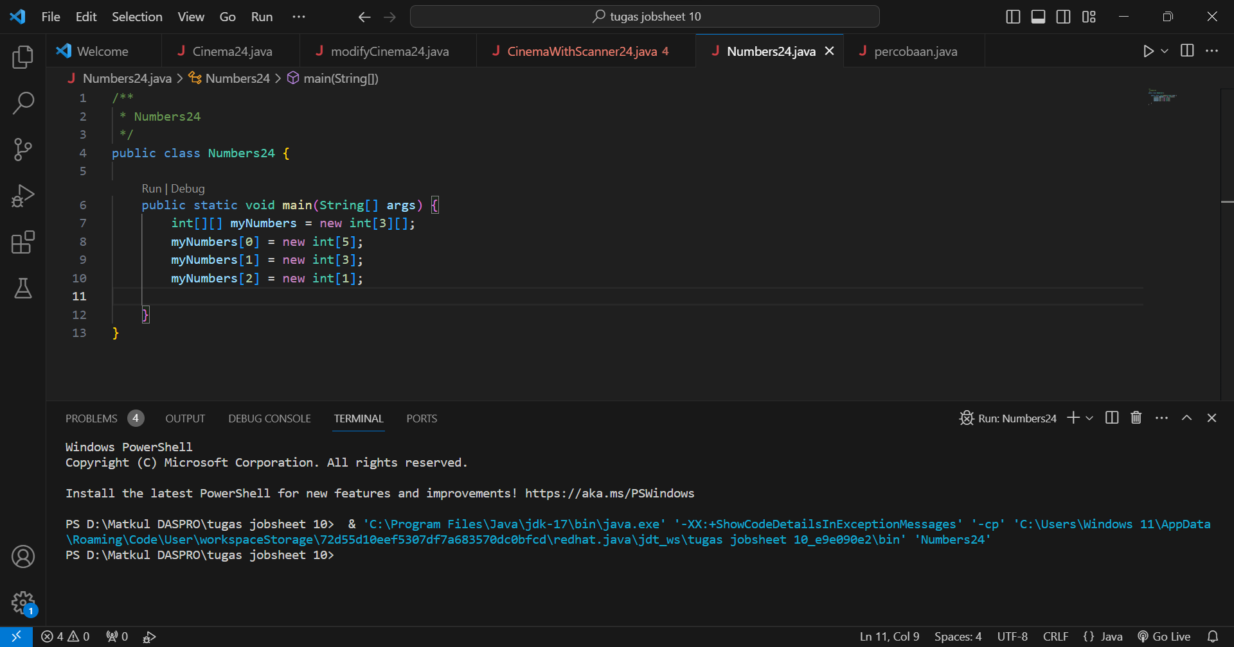

Questions!

1. Add the following program code: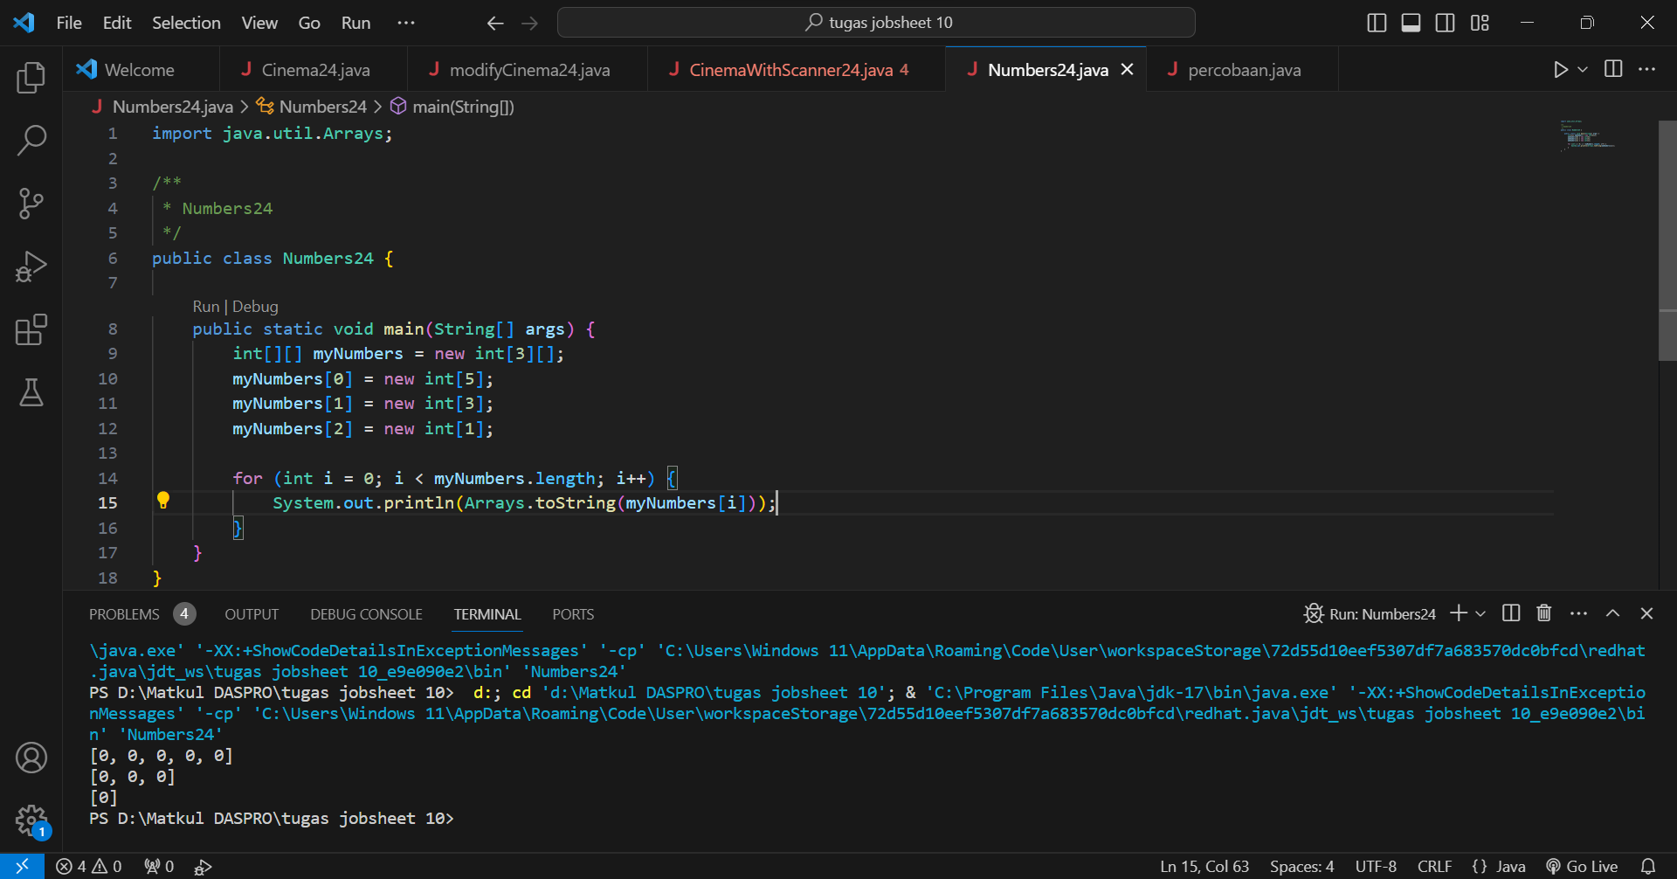
2. What is the function of Arrays.toString()?

The function of Arrays.toString() is to produce a depiction of a string that we write through the elements in the array, and of course array.toString() can display and read easily the contents of the array.

1. What is the default value for elements in an array with the data type int?

The default value for a pull element with int data type is 0, because when we create an array on int the first one starts from 0.

1. Add the following program code:

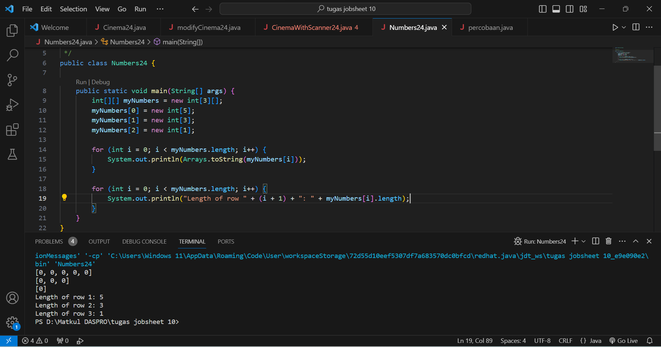

1. The myNumbers array has a different length for each row. How to make the length for each row the same? Can the array length be modified?

In Java code, the array that we have created has the same length and cannot be modified, and if the array myNumbers (two-dimensional) has a different length in each row then we cannot directly change the length in each row because the length of the array must remain unchanged after it is created.